1. “NaN” value display while click the search button without Department value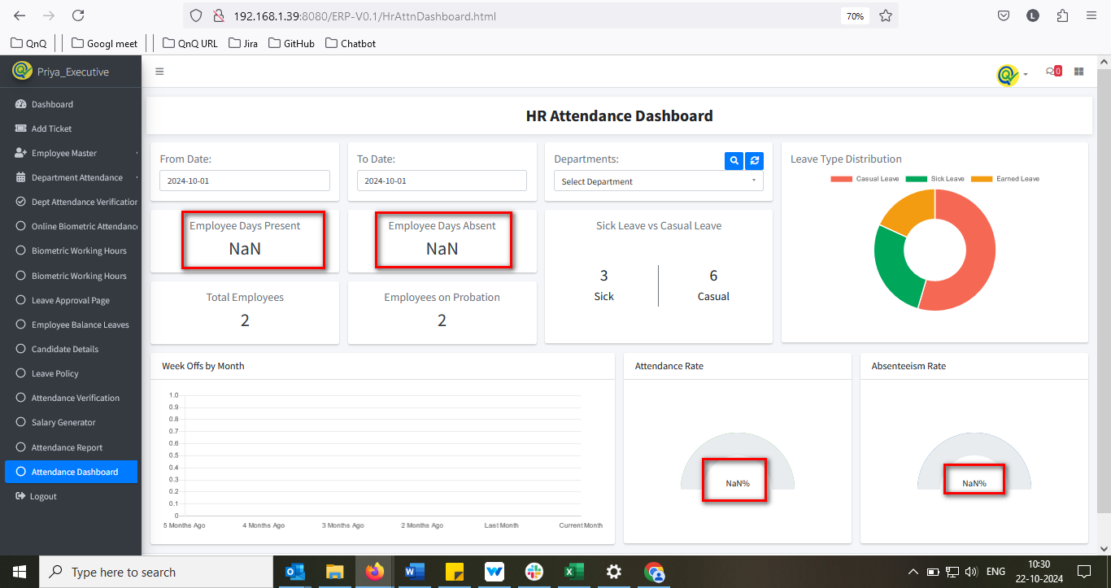//
2. Data’s display without Department value 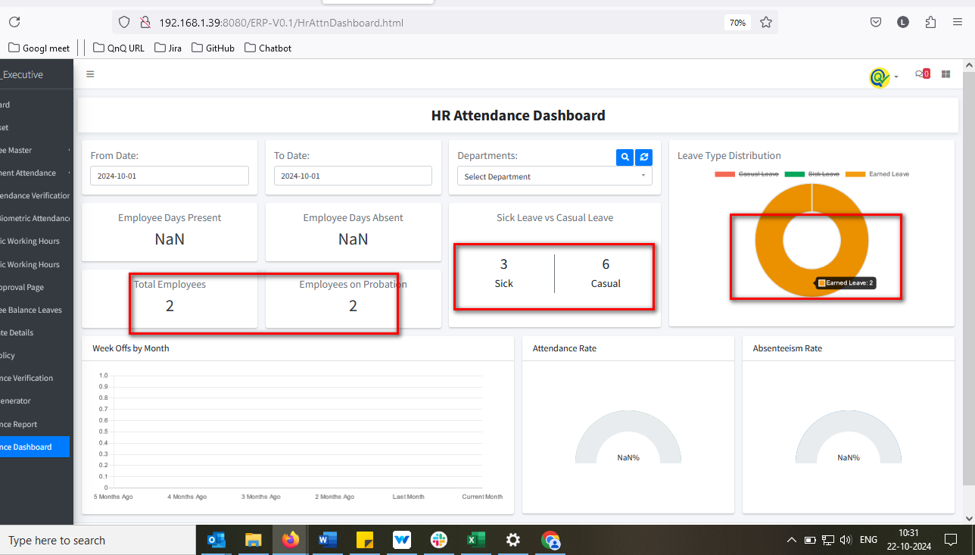//
3. Inconsistent values are displayed in the pie chart when hovering over 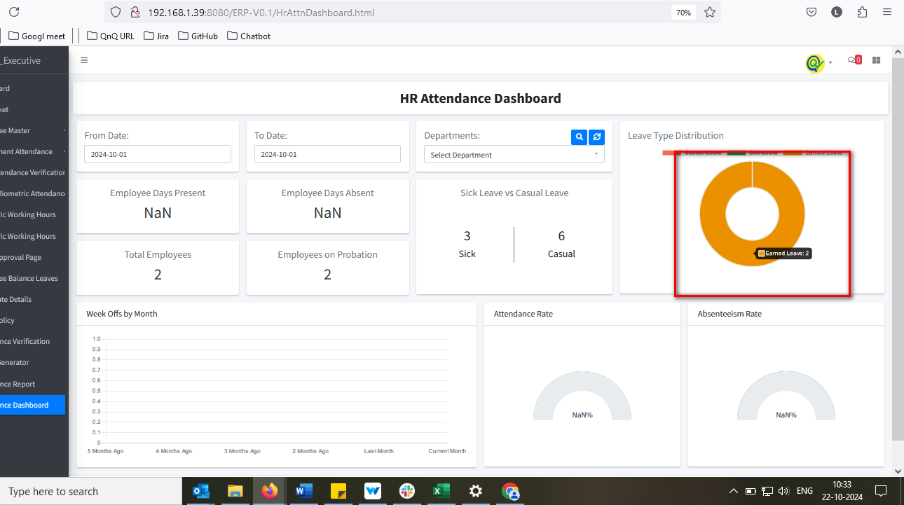 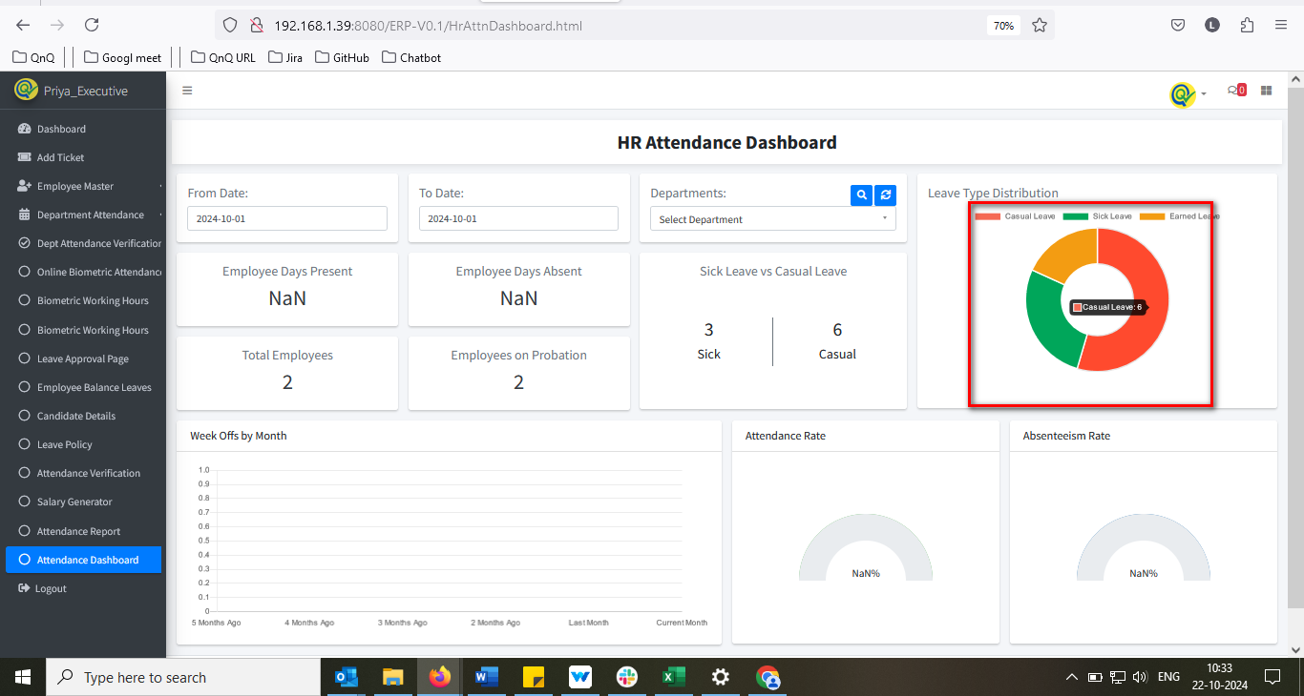 //
4. Given date value not getting clear while click refresh icon in webpage 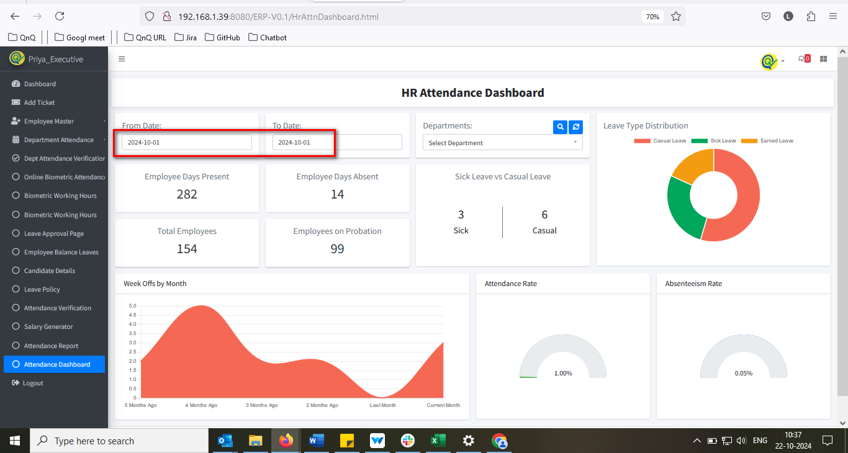 //
5. The date field permits letters and special symbols when pasting content 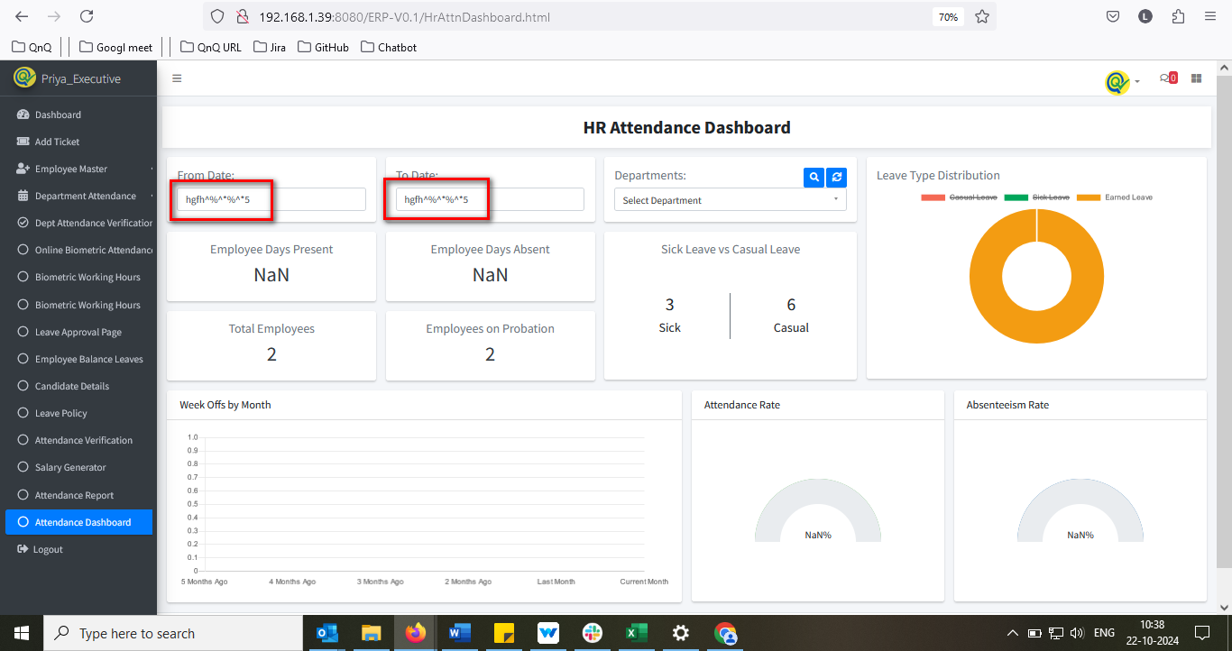 //
6. The system is displaying an incomplete list of leave types 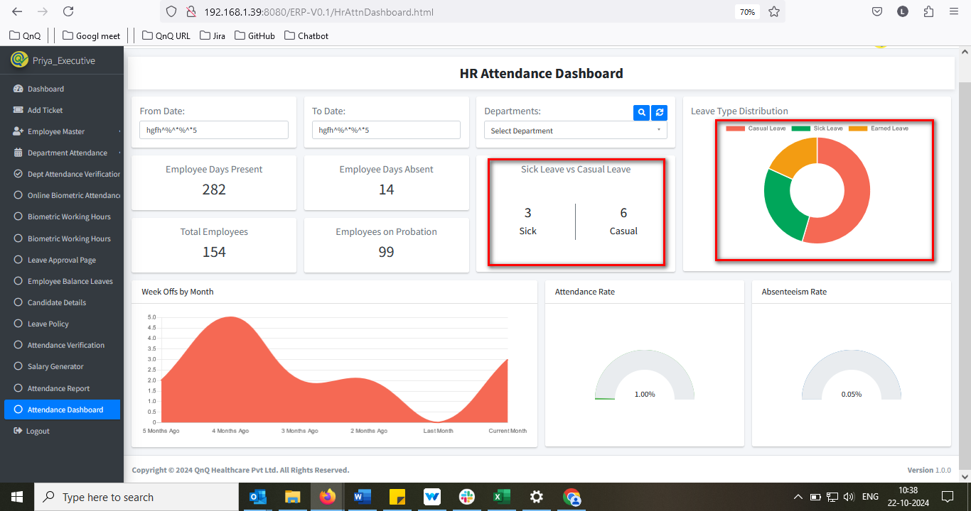 //
7. Mismatch Rate value display 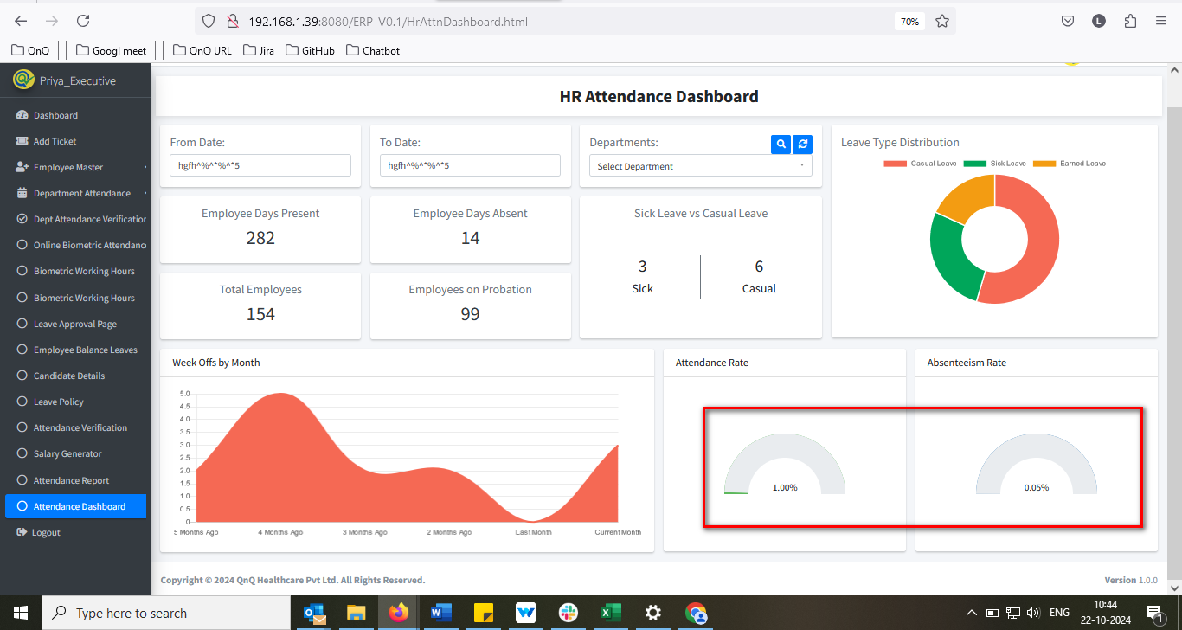 //
8. From and To date’s not display while navigate the page 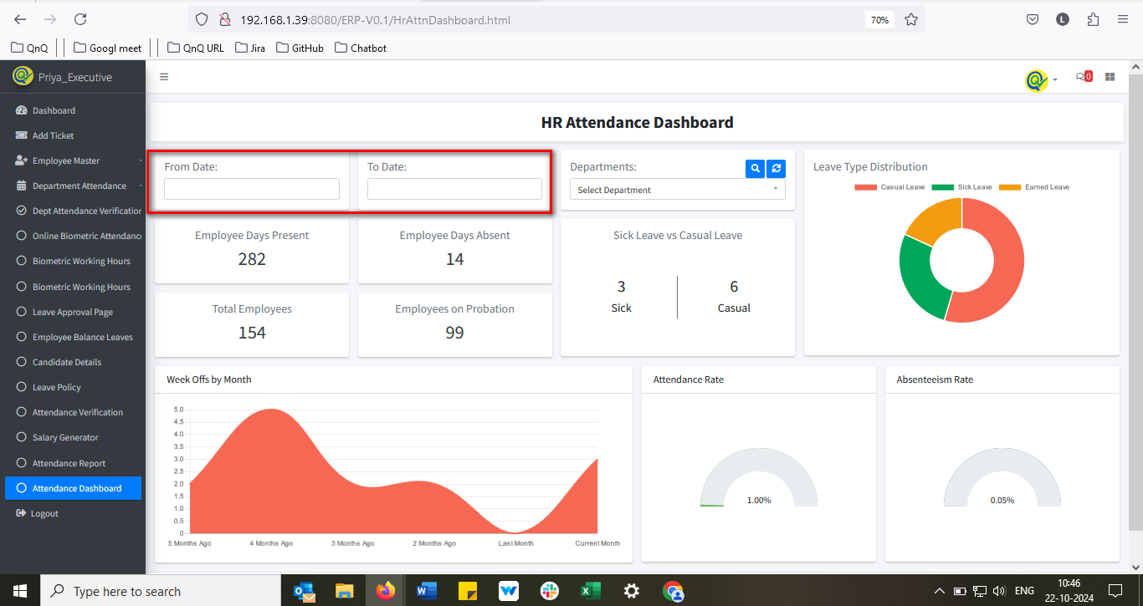 //
9. The attendance dashboard is failing to display leave records that have been approved by HR 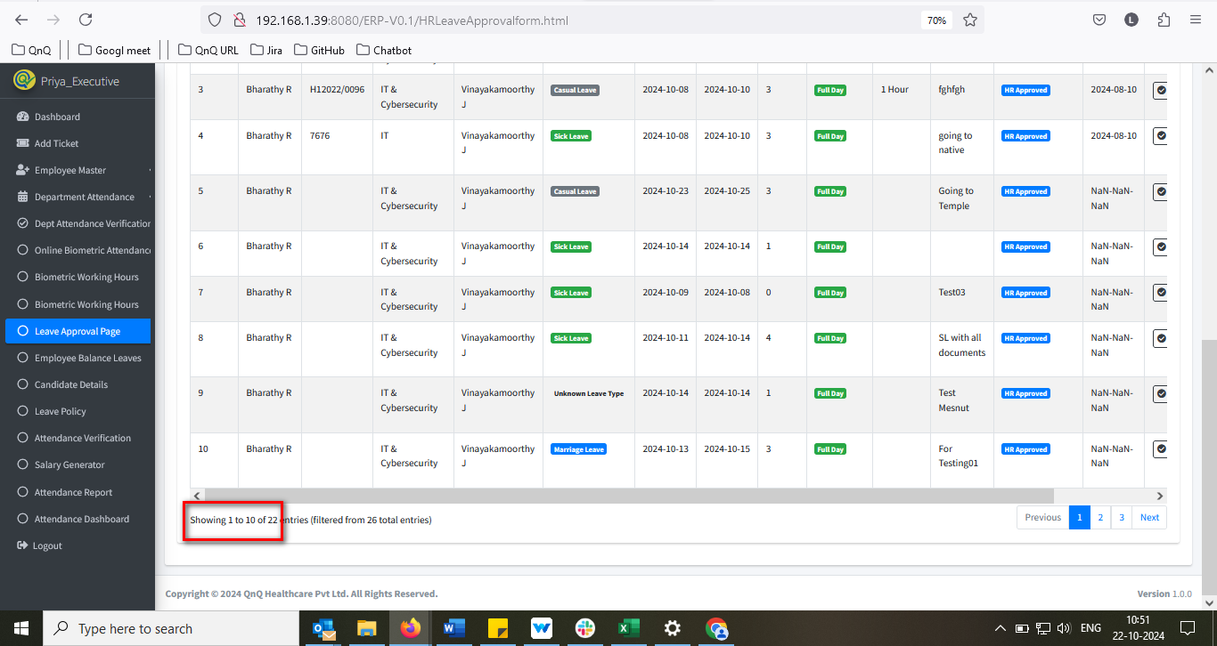 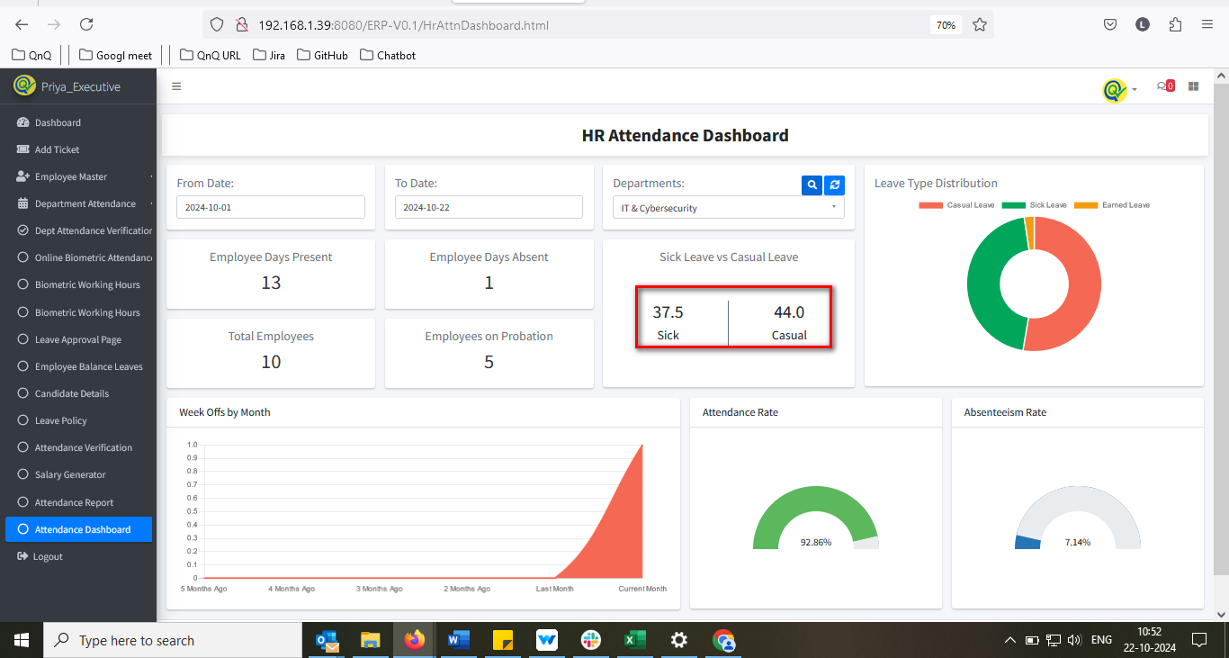 //
10. Tool tip not display for search and refresh icon 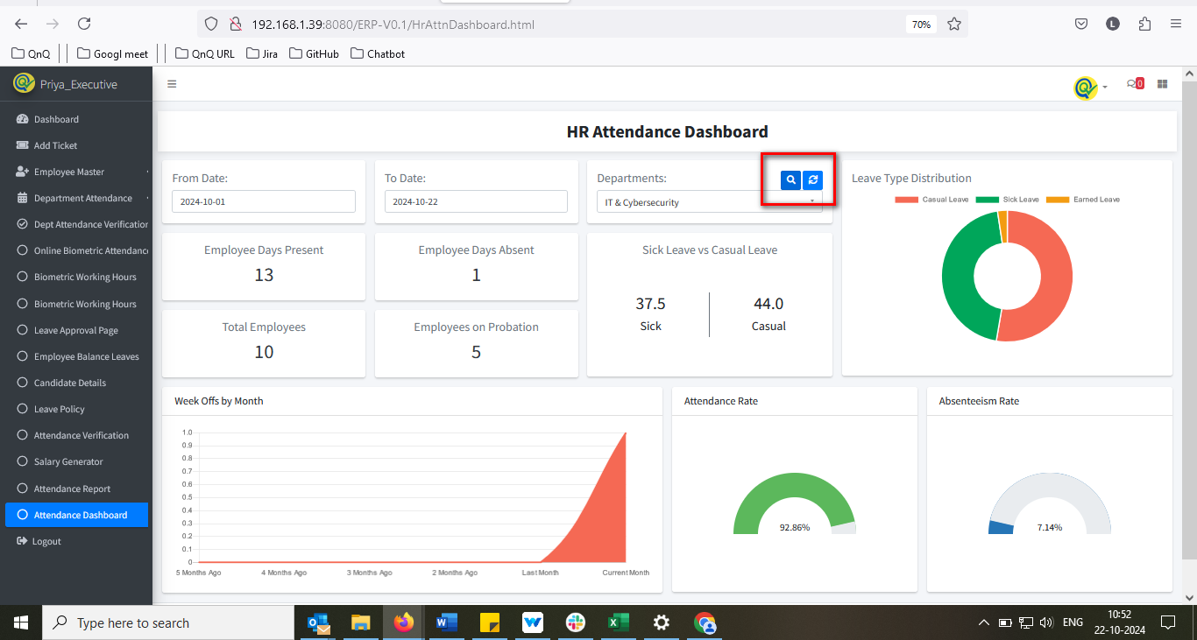//
11. Multiple dashboards display for Hr login  